**Appendix C. Screen Design**

Screen No. 1

Screen Name: Register Module

Narrative Overview: This module allows users to register so they can log in to the system.

Screen Layout:

Screen No. 2

Screen Name: Failed Register Module

Narrative Overview: This module will display a message when the user fails to provide all the required details during the registration process. The message will prompt the user to fill in all the necessary information correctly before proceeding.

Screen Layout:

Screen No. 3

Screen Name: Successful Register Module

Narrative Overview: This module will display a message when the user successfully registers. After the user clicks on any option, they will be able to proceed to log in and access the system.

Screen Layout:

Screen No. 4

Screen Name: Login Form

Narrative Overview: This module will allow the user to enter credentials to login.

Screen Layout:

Screen No. 5

Screen Name: Login Error Module

Narrative Overview: This module will display a message when the user enters incorrect login credentials. Please try again with the correct information.

Screen Layout:

Screen No. 6

Screen Name: Login Successful Module

Narrative Overview: This module will display a message when the user enters the correct login credentials. After the user clicks on any option, they will be directed to the Dashboard.

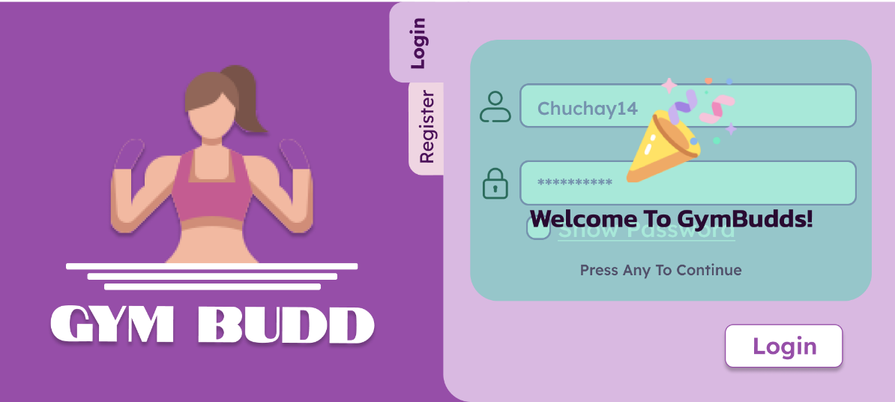Screen Layout:

Screen No. 7

Screen Name: Dashboard Module

Narrative Overview: This module will provide users with valuable insights on the platform's user bases, total registered members, gender distribution, active/present members, enrolled class data, and total earnings.

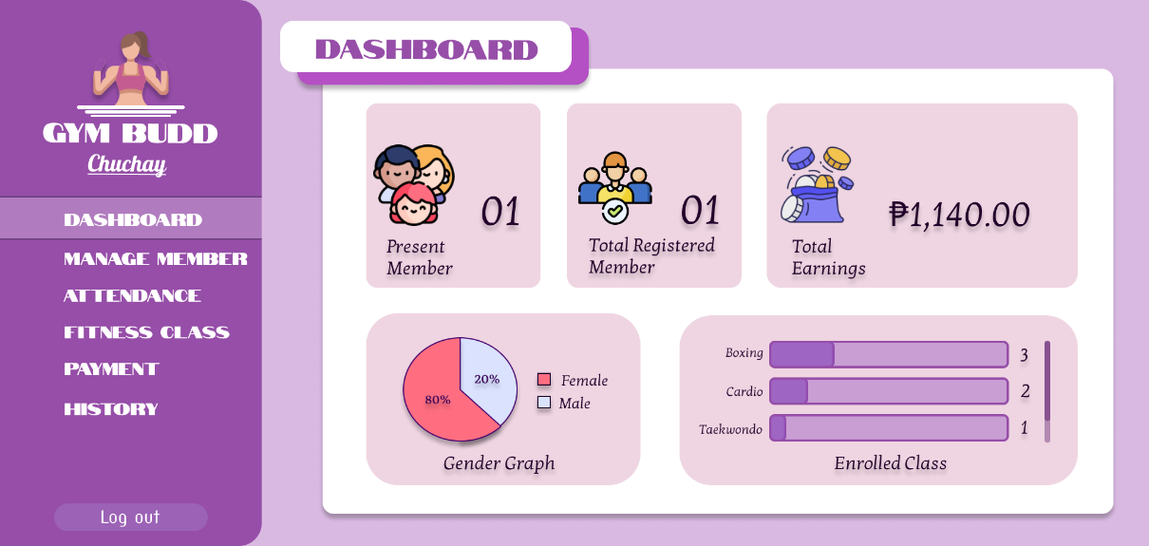Screen Layout:

Screen No. 8

Screen Name: Add Member Module

Narrative Overview: This module will allow the user to add new members to the Gymbudd.

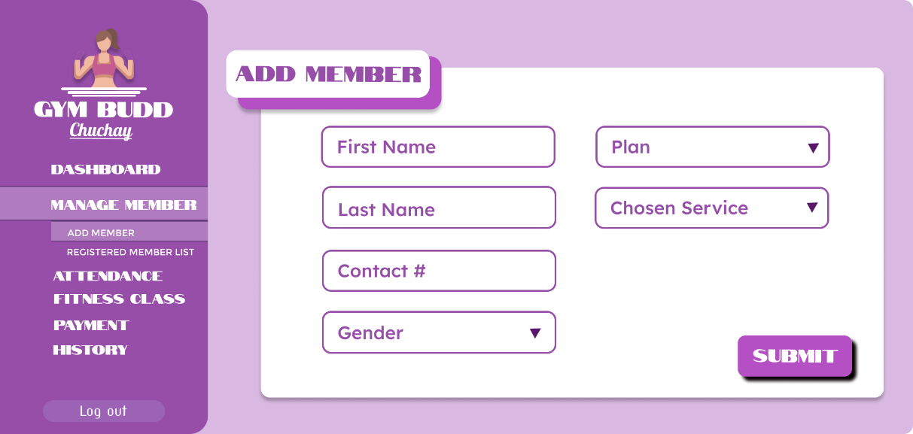Screen Layout:

Screen No. 9

Screen Name: Registered Member List Module

Narrative Overview: This module will allow the user to view the complete list of members registered on the Gymbudd.

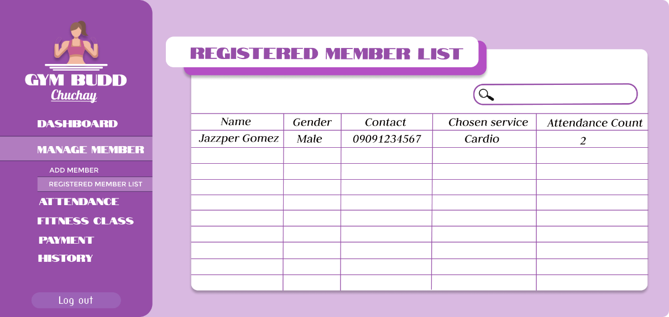Screen Layout:

Screen No. 10

Screen Name: Check-in/Checkout Module

Narrative Overview: This module will allow the use to record member attendance and track their sessions.

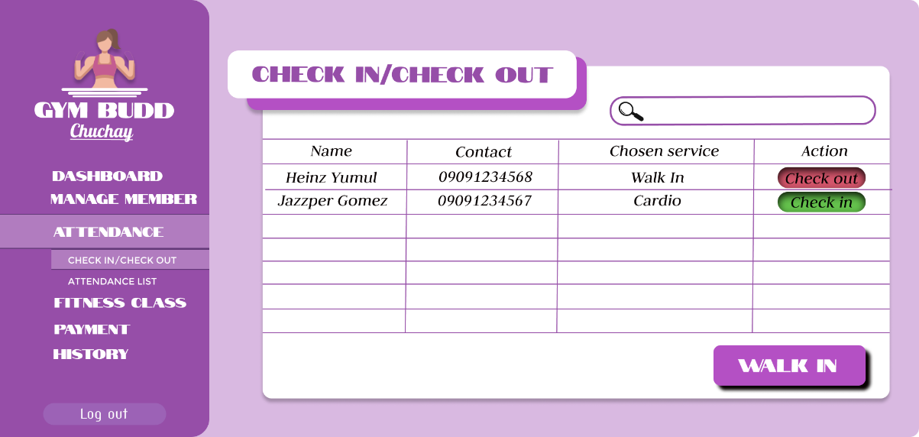Screen Layout:

Screen No. 11

Screen Name: For Walk In

Narrative Overview: This module will allow the user to add record those walk-in gym goers.

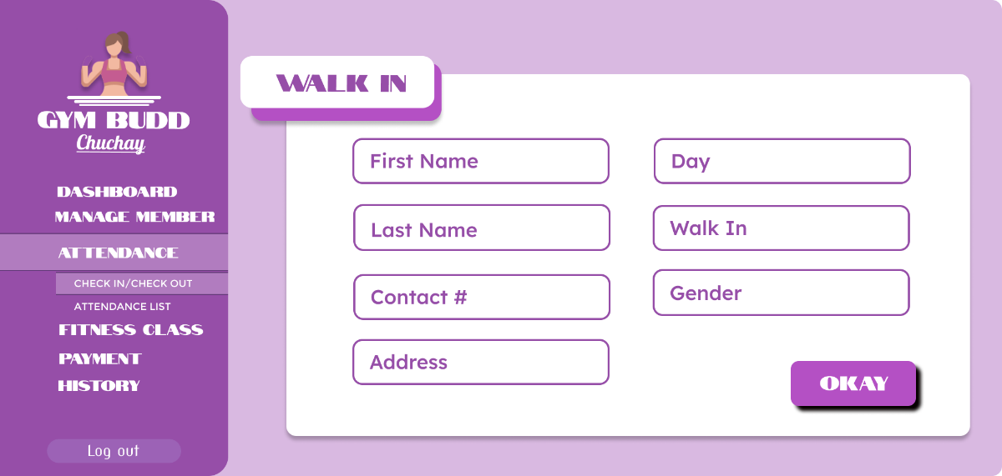Screen Layout:

Screen No. 12

Screen Name: Attendance List Module

Narrative Overview: This module will allow the user to view the overview of member participation over time.

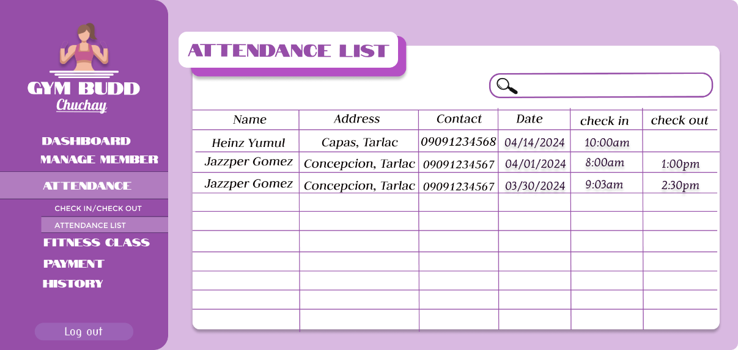Screen Layout:

Screen No. 13

Screen Name: Add Fitness Class Module

Narrative Overview: This module will allow the user to add new service to the Gymbudd.

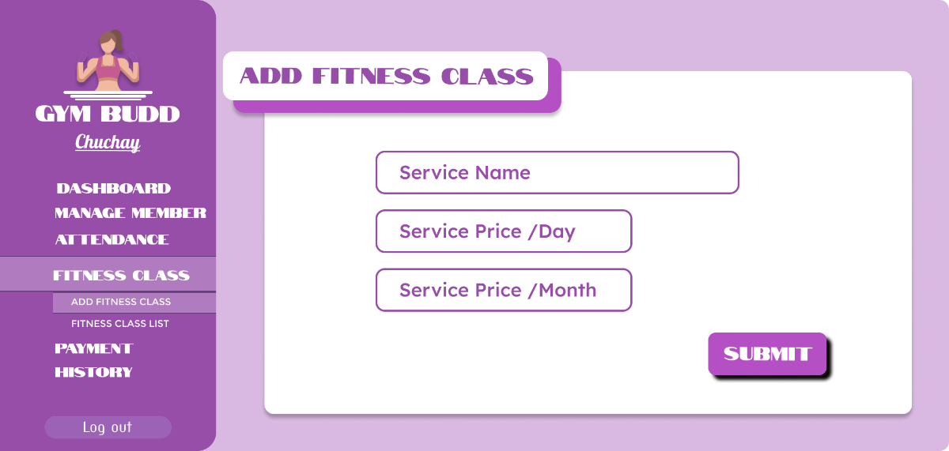Screen Layout:

Screen No. 14

Screen Name: Fitness Class List Module

Narrative Overview: This module will allow the user to provide a comprehensive list of all fitness classes available on Gymbudd.

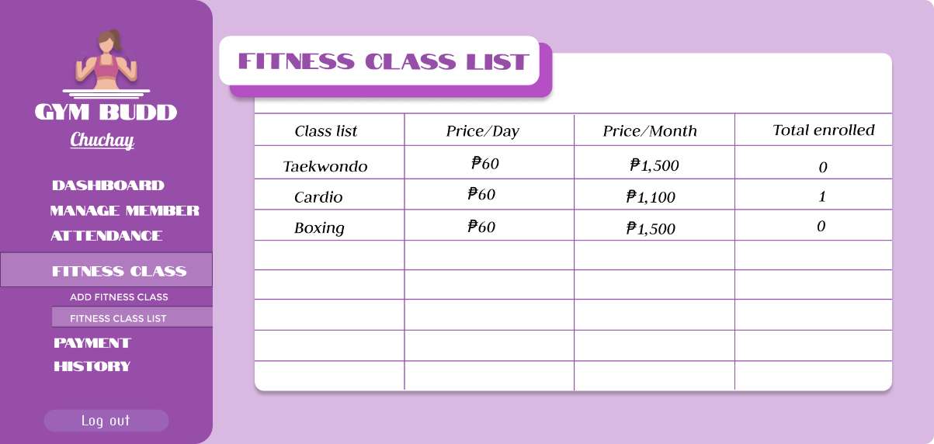Screen Layout:

Screen No. 15

Screen Name: Payment Module

Narrative Overview: This module will allow the user to handle member payments and financial records. Upon clicking on "PAY" button user will redirect to payment form.

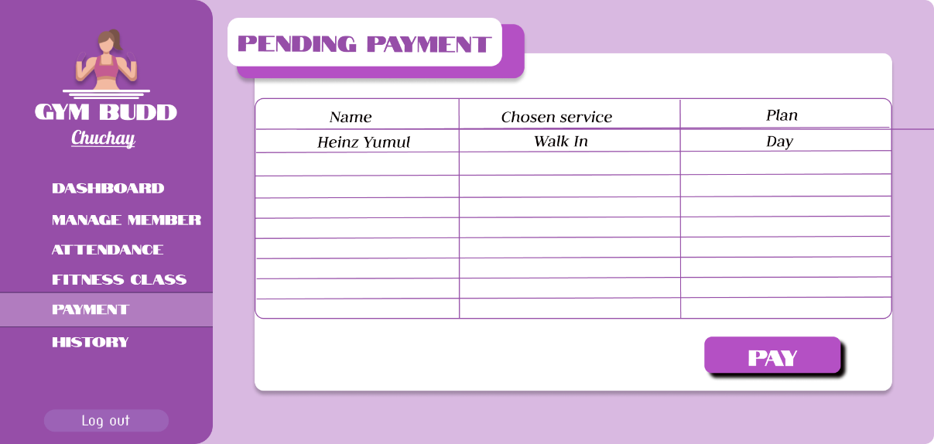Screen Layout:

Screen No. 16

Screen Name: Payment Form

Narrative Overview: This module allows users to make payments for the selected member. After clicking on the "PAY" button, a payment form will appear, displaying the amount that the selected member needs to pay.

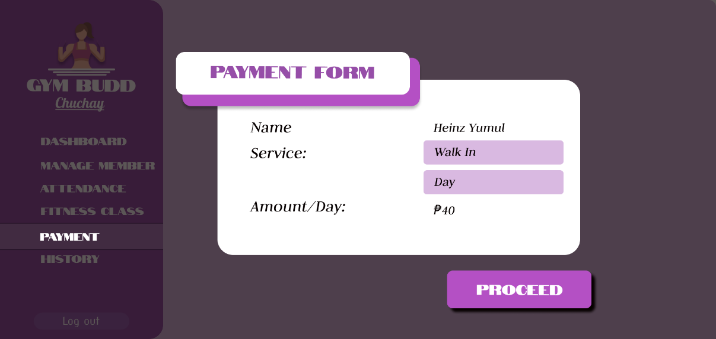Screen Layout:

Screen No. 17

Screen Name: Payment Receipt

Narrative Overview: Upon clicking the "PROCEED" button on screen number 15, a payment receipt will appear. The user will have the option to print the receipt and provide it to the member as proof of payment and then exit.

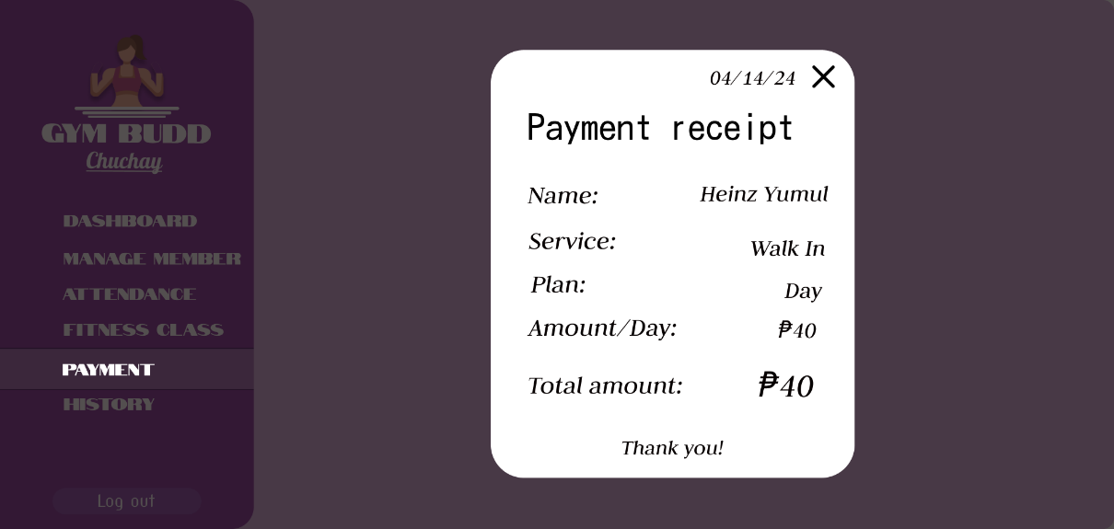Screen Layout:

Screen No. 18

Screen Name: Payment History Module

Narrative Overview: This module provides users with the ability to view their payment history.

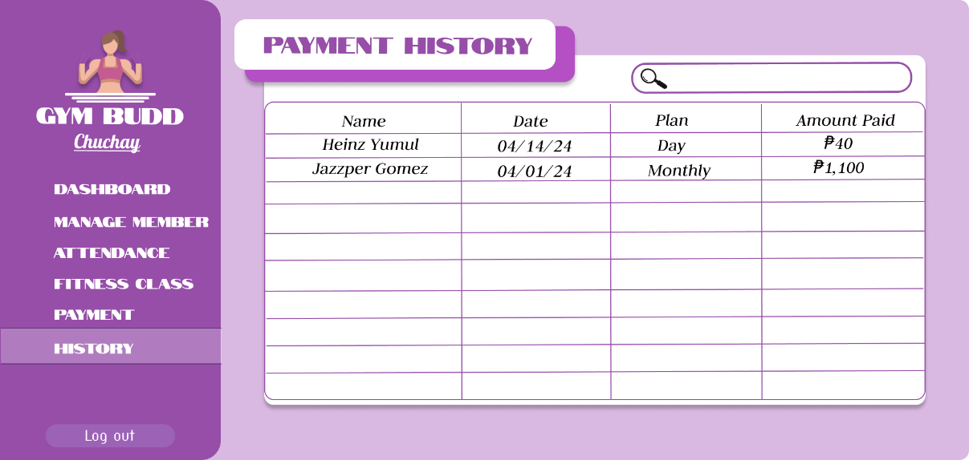Screen Layout:

Screen No. 19

Screen Name: Log Out Button

Narrative Overview: The "Log Out" button allows users to securely end their session and log out of their account.

Screen Layout:

